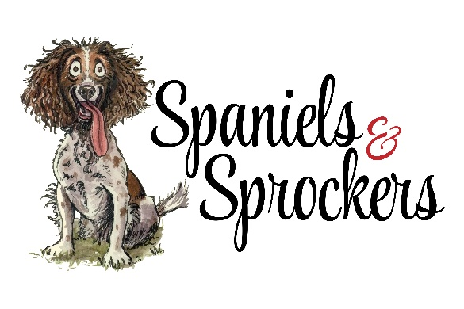
Michele Duivenvoorden
2383 Burnside Line
Severn, ON L3V 6H4
sprockerscanada@gmail.com
705-333-6587

Hello, my name is Michele Duivenvoorden and I’m excited that you’re interested in buying a puppy from me.
A non refundable deposit of $500 by etransfer is required for your pick of your puppy. Pick of puppy is in order of deposit on waiting list. Purchase price for the puppies are $1750 SPROCKERS and $1250 COCKALIERS Canadian and will include deworming, vet check & 1st vaccines.

Please complete the information below and return to me with your deposit.

NAME: ____________________________________________________________________________________________
ADDRESS: ____________________________________________________________ CITY__________________________
Province: _____________________________________________
Contact Numbers: ___________________________________________________________________________________
Email: _____________________________________________________________________________________________
When do you want a puppy? SPRING SUMMER FALL WINTER
Do you prefer a MALE or FEMALE? COLOUR PREFERENCE ________________________________________
Why do you want a SPROCKER SPANIEL __________________________________________________________________________________________________
__________________________________________________________________________________________________
What qualities and personality would you like in a dog? _____________________________________________________
__________________________________________________________________________________________________
What fears do you have about owning a puppy and having a dog? ____________________________________________
__________________________________________________________________________________________________
Are you looking for a companion dog, a show dog, an obedience/agility dog, and/or a hunting dog? _________________
Is everyone in your household excited about getting a puppy/dog? ___________________________________________

My goal is to ensure this puppy is a match for you; and I am hoping to share the journey with you and your new puppy as he or she grows in your family. MICHELE

